Benilde Trailblazer Startup Program Agreement

Article I. Parties
This Agreement is entered into by and between:
Startup Name: My startup
Representative: Designation:
Project Name: My startup
Brief Description of the Project:
Enterprise Address:
Incubator: DE LA SALLE-COLLEGE OF SAINT BENILDE
through the Hub of Innovation for Inclusion (“Benilde HIFI”), a DOST Technology Business Incubator
Incubator Representative: Paul Amerigo Pajo Designation TBI Manager
Incubator Address: 1049 P. Ocampo St., Malate, Manila, 1004 Metro Manila
Article II. Purpose
The Benilde Trailblazer Startup Program (“Agreement”) embodies the collaborative spirit between De La Salle-College of Saint Benilde through its DOST-accredited technology business incubator, the Hub of Innovation for Inclusion (“Benilde HIFI”) and My startup in their shared commitment to fostering innovation for inclusion and entrepreneurial growth.
2.1 The Benilde Trailblazer Startup Program (“BTS” or “Program”) is designed as a progressive startup development program that aims to empower Benildean entrepreneurs in their pursuit to launch a successful startup venture, while meeting their specific needs.
2.2 By joining the BTS Program, My startup acknowledges and embraces the mission of DLS-CSB to initiate programs and activities fostering innovation for inclusion through the development of founder, creative tech product, and business. This commitment seeks to create a dynamic and inclusive entrepreneurial ecosystem within the Benildean community.
Article III. Terms and Conditions
The parties agree to the following:
3.1 Level of Incubation and Duration
- Level 1 - Founder Development: 3 months from ______ until _______.
- Level 2 - Creative-Tech Product Development: 3 months beginning ______ until _______.
- Level 3 - Enterprise Accelerator: 3 months beginning _____ until _______.
- Level 4 - BTS Full Program: 9 months beginning February 2026 until October 2026.
- + Entitled to 2 years access to incubation support/facility starting from the beginning of agreement-—subject to preview of performance of startup.
- Scope

This agreement outlines the collaboration between My startup and Benilde
HIFI, wherein Benilde HIFI will offer incubation program and support services under
Level 4, as defined in Annex A, while My startup will focus on delivering a comprehensive incubation journey combining founder development, creative-tech innovation, and enterprise growth. Upon achieving the milestones outlined in Annex C, My startup will be acknowledged as a graduate of the Program.
- Responsibilities of the Parties
3.3.1 Benilde HIFI shall:
- Provide business incubation and business development services to My startup as described in Annexes B and C.
- Allow My startup to use its logo in its promotional/marketing
collaterals.
3.3.2 My startup and its members commit to actively engage in the Program, leveraging the resources, tools and support provided by Benilde HIFI, and:
- Commits to work with Benilde HIFI in completing the incubation program deliverables specified in Annex C.
- Attend the mentoring and training sessions listed under Annex C represented by at least one co-founder, as well as the consultation sessions with the assigned senior advisor(s);
- Submit trimestral updates via Benilde Trailblazer Startup Check-ins on the progress of My startup to Benilde HIFI, focusing primarily on the status and readiness of the enterprise’s product/service, market, and team, as outlined in Annex D to integrate Innovation Readiness Level.

- Include the Benilde HIFI logo in its marketing collaterals and acknowledge, in perpetuity, the support received from DLS-CSB and Benilde HIFI, as its DOST accredited technology business incubator in all materials, publications, and public presentations, PR and marketing engagements (i.e.,TV/radio interviews, podcasts, vlogs, PR releases on print, etc.), and allow Benilde HIFI to repost, report, and share them through its own channels.
- During and post-BTS Program and upon request of Benilde HIFI
- Act as mentors or coaches in their specific vertical for startups sharing the same vertical.
- Participate actively in Benilde HIFI events, contributing as a resource, coach, mentor, or participant.
- Inform and secure the approval of Benilde HIFI prior to applying to another incubation program during the effectivity of the agreement.
- If a corporation, execute a board resolution authorizing the CEO, or any board member as company representative to enter into an agreement with DLS-CSB through Benilde HIFI, with the same provisions presented in this agreement. In case My startup is not yet incorporated or registered at the time of the execution of this agreement, all members of the My startup must sign this agreement, and upon incorporation, shall follow the aforementioned condition(s). If the My startup is a spin-off of DLS-CSB or a Research and Development Team and is not in a position to incorporate or register during the period of this agreement, but is able to raise funding through grants, revenue or other forms of investment, the My startup Project Leader or authorized representative shall endorse or authorize activities provided in this agreement.
- Allow Benilde HIFI to take photographs, voice recordings, and/or video recordings of My startup during Program events and activities, including their testimonials (the “Records”), and grant DLS-CSB perpetual, worldwide and royalty-free use rights to
- use, distribute, broadcast, display, edit, translate or otherwise disseminate the Records, either alone or in conjunction with supporting information, such as the name of the Startup, voice, photographs, likeness and biographical data, in any and all media now known or hereafter developed, for purposes of documentation, research, accreditation, fund raising, investor relations, marketing, publicity/ promotion of DLS-CSB and/or Benilde HIFI, and educational purposes aligned with the mission of DLS-CSB;
ii. license others to do the same.
In these undertakings, DLS-CSB shall endeavor to protect the intellectual property rights of the My startup
i. Release DLS-CSB, Benilde HIFI, its trustees, officers, employees, and agents, licensees and assignees, from any and all claims arising out of their participation in the BTS Program and all authorized uses of the Records, including claims for intellectual property infringement and/or unfair competition.
3.3.3 Financial Commitment. In return for the support provided by DLS-CSB through Benilde HIFI and to contribute to the sustainability of the Program, My startup commits to:
- Make a pledge to DLS-CSB for the account of Benilde HIFI an amount equivalent to up to five percent (5%) of the total grant and/or investment assisted and/or facilitated by Benilde HIFI.
i. The commitment extends to every grant, investment, or financial milestone obtained by My startup, occurring within twelve (12) months post the Program's completion. The commitment encompasses, but is not limited to, the achievement of specific financial goals, such as:
- Grants featuring an approved line item budget for Incubation Services or Strategic Business Development Services, or their equivalent;
- Total equity investment (excluding any investment offer from
DLS-CSB) amounting to at least One Million Pesos
(P1,000,000.00);
- Annual gross revenue running at Two Million Pesos
(P2,000,000.00) and above;
- Mergers or outright acquisition of the Company. In these cases, the commitment applies to the fair market value of the net consideration received by My startup after deducting reasonable transaction costs.
- The pledged amount may be disbursed either in installments or as a lump sum, at the option of the My startup, within twelve (12) to twenty-four (24) months following the receipt of grant funds and/or investment.
- This commitment must be honored by any assignees or transferees of My startup and included in their written agreement.
- Allow DLS-CSB and/or its subsidiaries the first opportunity to invest in the enterprise, at the option of DLS-CSB. The terms of such investment shall be negotiated in writing between DLS-CSB and/or its subsidiary and the My startup in good faith, and under terms mutually beneficial to the parties.
3.4 Mutual Responsibilities
3.4.1 Intellectual Property
All intellectual property rights to the work, design, or inventions of My startup shall at all times remain (as between the parties) the property of My startup, subject to the applicable provisions of DLS-CSB Intellectual Property Rights Policy and existing intellectual property laws.
Furthermore:
- By participating in the BTS Program, My startup affirms that it has conducted due diligence and that no part of its project or enterprise infringes upon the intellectual property rights of third parties. My startup further agrees to hold harmless and indemnify DLS-CSB and Benilde HIFI against any claims or liabilities arising from alleged intellectual property infringement, including associated legal costs.
- Prior to commencing the incubation program, the My startup founders shall identify and acknowledge their individual contributions in writing. The My startup founders shall agree in writing on the ownership and utilization of intellectual property rights, including scenarios involving changes in the startup's membership. In cases where team members have existing registered intellectual property rights related to the project, such rights shall be assigned to the new corporation to be formed, if applicable. Additionally, any intellectual property rights to be registered during the Program shall be done in the name of this new corporation, if already registered. This is to ensure clear ownership and alignment of intellectual property rights within the My startup facilitating a smooth transition in cases of membership changes and promoting the collective success of the venture.
- In the event that My startup decides not to pursue its project and to transfer its intellectual property, My startup grants to DLS-CSB and/or its subsidiaries the right of first refusal to be the assignee or transferee of the intellectual property rights.
- My startup may appoint DLS-CSB, through Benilde HIFI, its subsidiaries, or authorized agents, as My startup's attorney in fact, with the authority to execute all acts necessary to protect, manage, commercialize, and enter into agreements involving the intellectual property. This includes, but is not limited to, collaboration agreements, technology transfer agreements, licensing, and any other agreements with third parties deemed necessary for the development, utilization, or commercialization of the work, design, invention, or technology developed by My startup and its corresponding intellectual property rights.
- This provision is subject to the provisions of the DLS-CSB Intellectual Property Rights Policy and the mutual agreement of both parties. Any assignments or agreements made under this provision shall be executed in writing.
3.4.2 Non-disclosure
All parties shall maintain strict confidentiality of all matters and details pertaining to this agreement as well as the terms in this document. All parties agree that for the duration of this agreement and within two (2) years after the expiration or termination of this agreement for any cause, STARTUP shall not exploit, use or disclose any material developed in connection with this agreement without the prior notice to and consent of HIFI.
3.4.3 Non-compete
My startup agrees not to compete with other STARTUPS incubated by HIFI in the same target market of the enterprise, without prior consent of HIFI for two (2) years from the expiration or termination of this agreement.
3.4.5 Data Privacy
The parties shall comply with applicable provisions of Republic Act No. 10173 or the Data Privacy Act of 2012, its implementing rules and regulations, and the issuances and circulars of the National Privacy Commission, as well as other applicable personal data privacy and security laws and regulations. At all times, both parties shall implement the appropriate and reasonable level of organizational, physical, and technical security measures to ensure the confidentiality, integrity and accessibility of personal information that is processed. Personal data disclosed by both parties shall only be used for the intended purpose and shall only be retained until it serves such purpose, after which it shall be securely disposed of.
3.5 Termination
3.5.1 Either party may terminate this agreement, provided that a one (1) month notice is given to the other. The notice period commences from the date of acknowledgment of receipt of the termination decision. A valid and justified reason is required for the termination decision, regardless of which party initiates the termination.
3.5.2 Where the My startup initiates the termination of the agreement with valid justification, and such termination is accepted by Benilde HIFI, the My startup undertakes to:
- Participate in a conclusive closing meeting of the program and evaluation to analyze any project shortcomings, if applicable, and explore the feasibility of potential recovery under another project leader.
- Return all resources and materials, financial and otherwise, received from Benilde HIFI during the Program and refrain from referencing Benilde HIFI incubator support in the future.
3.5.3 Benilde HIFI may initiate the termination of this agreement and end the support to the My startup in any of the following cases:
- The My startup, its project or enterprise is no longer focused on fostering innovation for inclusion and entrepreneurial growth;
- Despite multiple warnings, the My startup unreasonably refuses to follow recommendations or benefit from guidance;
- My startup or any of its members intentionally hides information, hindering quality coaching, or provides false details about the project;
- My startup consistently fails to meet the weekly/monthly time commitment to the incubation program, and there is insignificant progress between consecutive operational meetings;
- The continued participation of the My startup negatively impacts the Program's operations;
- The My startup Team or any of their team members joins another incubation program involving the same project during the effectivity of the agreement without notice to and approval of Benilde HIFI.

Conforme:
My startup
< Founder Name > | < Position > | < Signature >
< Founder Name > | < Position > | < Signature :

DE LA SALLE-COLLEGE OF SAINT BENILDE INC.
HUB OF INNOVATION FOR INCLUSION (HIFI) - DOST Technology Business Incubator
Paul Amerigo Pajo | TBI Manager, Benilde HIFI
Benhur Ong  Witnesses: | Chancellor, DLS-CSB
< Name of Witness > | < Position > | < Signature >
For Benilde HIFI
Ar. Alexander Abear | Incubation Management Unit Head

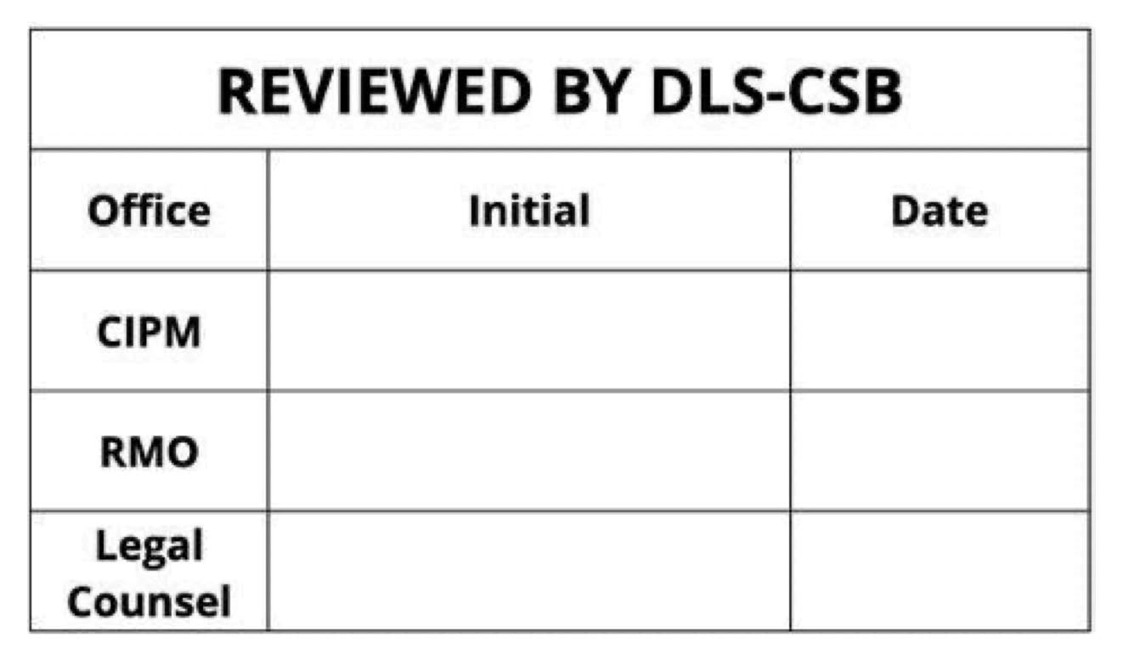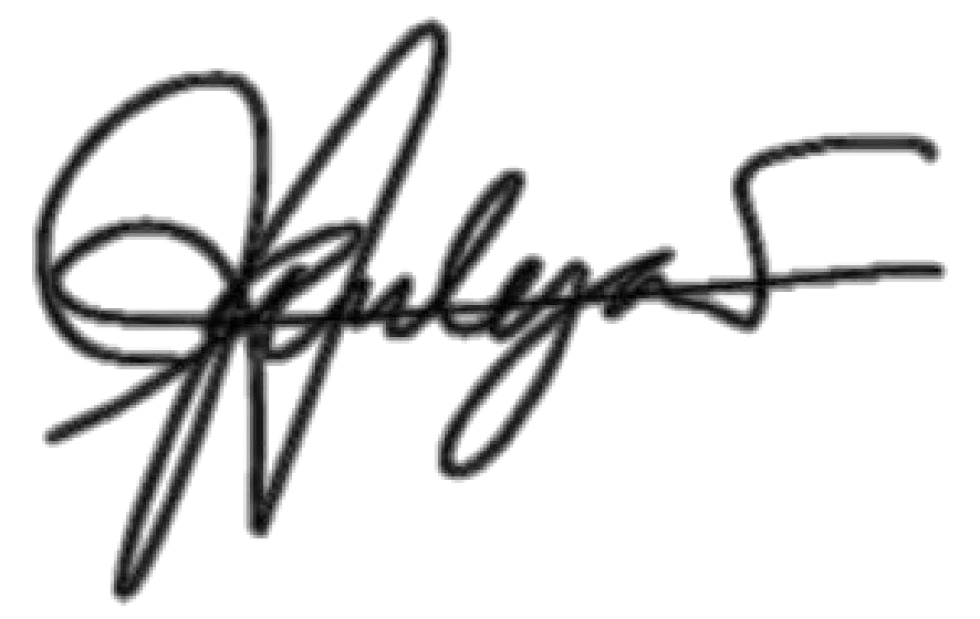

Ma. Janice R. Tejano 20 May 2025
Michelle Ann M. Escalona
22
May
2025

Annex A: BTS Incubation Program Levels

Levels | Objectives | Scope
Level 1: Founder Development  Duration: 3 months | Build entrepreneurial leadership, strategic vision,  and ecosystem engagement among founders. | - Lasallian Traditions: Understanding the principles of innovation and inclusion as part of Lasallian values.  - Purpose Mapping:  Helping founders identify their 'ikigai' and align it with their startup's purpose.  - Ecosystem Mapping: Training founders to understand and navigate the innovation and inclusion ecosystem.  - Strategic Visioning: Goal setting and understanding the role of startups in solving real-world problems.  - Startup 101: Introducing startups as vehicles for innovation, design, and community impact.  - Leadership Workshops: Strengthening decision making, communication, and problem-solving skills.  - Networking and Mentorship: Building connections with industry professionals, entrepreneurs, and mentors.

Level 2: Creative-Tech Product Development  Duration: 3 months | Guide startups in creating and refining innovative products with validated market demand. | - Prototyping and MVP Development: Designing and testing minimum viable products through user feedback loops.  - Design Thinking:  Applying user-centric design principles to solve real-world problems effectively.  - Market Research: Conducting customer interviews, surveys, and competitive analysis to identify needs and opportunities.  - Technical Expertise: Partnering with engineers, designers, and labs for product iteration.  - IP Management:  Understanding IP strategies, protection, and commercialization pathways.  - Creative Collaboration: Encouraging partnerships between creative and tech teams to innovate effectively.
Level 3: Enterprise  Development  Duration: 3 months | Enable startups to achieve funding readiness, establish partnerships, and prepare for scaling operations. | - Investor Readiness: Pitch preparation, investment proposals, and equity structuring.  - Strategic Marketing: Creating sales pipelines, scaling customer acquisition, and refining branding strategies.  - Financial Management: Budgeting, unit economics, fundraising strategies, and securing grants or pre-seed funding.  - Legal Compliance: Addressing co-founder agreements, business registration, and regulatory frameworks.  - Strategic Partnerships: Building relationships with corporate players, government agencies, and industry networks.
Level 4: BTS Full Program  Duration: 9 months | Deliver a comprehensive incubation journey combining founder development, creative-tech innovation, and enterprise growth. | - Integrated Learning: Combines training, mentorship, and resources from Levels 1–3.

Annex B: BTS Incubation Services

Incubation Level | Incubation Services Inclusions | Value
L1, L2, L3, L4 | 1.Basic access to facilities  - Use of Benilde HIFI address for mail and business registration  - Telephone access  - Internet access  - Use of 2 co-working seats  - Additional co-working seats may be availed upon request; and  - Subject to availability and operations schedule of Benilde HIFI.  - Use of conference/meeting room  - Video conferencing facility | P360,000.00 -  1,080,000.00 per year x 2 years
L1, L4 | 2. Ideation and prototyping (as applicable)  - Needs assessment  - Design thinking - P 132,835.00 (in cost)  - Prototyping support  - IP diagnostics | P 250,000.00
L1, L2, L4 | 3. Startup buildup  - Startup community connections and engagement  - Access to seminars and workshops  - Invitation to networking events | P 250,000.00
L2, L3, L4 | 4. Assistance in grant application, proposal writing and management | P 250,000.00
L2, L3, L4 | 5. Advanced business support services  - Startup management  - Marketing and branding  - Intellectual property services  - Venture creation  - Company registration and business set-up  - Initial regulatory compliance  - Initial policy, legal agreements and documents  - Legal advisory services  - Tax advisory services  - Mentoring sessions for business organization and product development  - Support in marketing and financial aspects of business development  - Guidance from industry experts and partners  - Arranging for pitch to investors, partners, sub-licensees, industry players  - Connecting with potential investors and providing referrals | P 250,000.00

- Help with crafting and negotiating investment proposals
- Building connections within the industry
- Aid in creating sales proposals and navigating sales negotiations
 | TOTAL VALUATION OF INCUBATION PROGRAM SERVICES | P1,500,000.00 -  2,000,000.00

Annex C: BeTS (Benilde Trailblazer Startup) Training Program
Pillar 1: Founder Development
Objective: Build leadership, ecosystem-building skills, and a purpose-driven mindset in founders, grounded in Lasallian traditions of innovation and inclusion.
Training Session | Learning Outcomes / Expected Output
Understanding Lasallian Traditions in Innovation and Inclusion | A deep appreciation of Lasallian values and their application in fostering innovation and inclusion.
Startup 101: Introduction to Startups | A clear understanding of the startup ecosystem, entrepreneurial principles, and the value of startups in driving change.
Understanding and Mapping the Innovation+Inclusion Ecosystem | Mapped innovation and inclusion ecosystem, with identified partners and opportunities for collaboration.
Identifying Your Purpose and Ikigai | A clear personal purpose statement and alignment with the startup's mission.
Strategic Visioning and Goal Setting | Defined strategic vision, goals, and actionable milestones for personal and startup growth.
Understanding the Role of Innovation, Inclusion, and Design in the World | A comprehensive understanding of how innovation, inclusion, and design address global challenges.
Why Start a Startup | Articulated reasons for starting a business, supported by personal and professional motivations.
Ecosystem Building and Community Engagement | A growing network of mentors, industry experts, and peers within the innovation ecosystem.

Pillar 2: Creative-Tech Product Development
Objective: Enable startups to achieve problem-solution fit and product-market fit using KTH Innovation Readiness Levels and Design Thinking principles.
Training Session | Learning Outcomes / Expected Output
Empathy Mapping and Customer Personas (CRL 1–3) | Detailed customer personas and empathy maps that reflect real user needs and pain points.
Customer Journey Mapping (CRL 3) | A mapped customer journey, identifying key moments for engagement and improvement.
Prototyping and User Testing (TRL 4) | Developed low-fidelity prototypes tested with real users, generating actionable feedback.
Design Thinking and Ideation (TRL 3) | A set of innovative, user-centered solutions addressing validated problems.
Minimum Viable Product (MVP) Development (TRL 5) | A functional MVP tested in relevant environments with initial user feedback.
Product Development Roadmap (TRL 6) | A step-by-step product development plan, including timelines, features, and priorities.
Market Research and Competitive Analysis (BRL 3–4) | A market research report highlighting opportunities, challenges, and competitor insights.
User Feedback Integration (CRL 4–6) | Iterative product improvements based on structured user feedback sessions.
Intellectual Property (IP) Management (IPRL 3) | Identified core IP and filed for appropriate protection, with a commercialization strategy.

Pillar 3: Enterprise Development (Pre-Accelerator)
Objective: Prepare startups to secure grants, funding, and investor buy-in for sustainable scaling.
Training Session | Learning Outcomes / Expected Output
Introduction to Startup Financing (FRL 1–3) | A clear understanding of funding options (grants, equity, debt), valuation basics, and fundraising processes.
Understanding Investor and Grant Requirements (FRL 2–3) | Detailed knowledge of what investors and grant organizations look for, including financial sustainability and impact.
Startup Financial Literacy (BRL 3, FRL 2) | Accurate financial statements (P&L, cash flow, balance sheet), budget planning, and financial forecasting.
Unit Economics and Revenue Models (BRL 4) | A defined revenue model and key unit economics (CAC, LTV, breakeven points).
Building a Scalable Business Model (BRL 5) | Refined business model with scalability options and a clear value proposition.
Team Dynamics and Leadership Development (TMRL 5–6) | A cohesive team with clearly defined roles, responsibilities, and a shared vision.
Partnership and Ecosystem Building (TMRL 6) | A network of partners, mentors, and collaborators to support growth and scalability.
Legal Compliance and Risk Management (IPRL 4, FRL 3) | Completion of necessary legal requirements (business registration, founders’ agreements) and risk mitigation strategies.
Developing a Go-to-Market Strategy (BRL 6) | A launch plan targeting specific markets, backed by research and validated productmarket fit.
Investor Relations and Communication (FRL 4) | Clear communication strategies to engage potential investors and build relationships.
Crafting a Winning Pitch Deck (FRL 5) | A compelling pitch deck highlighting the startup’s value proposition, impact, financials, and scalability.
Pitch Practice and Feedback (FRL 5) | Polished pitch delivery and feedback from mentors, peers, and potential investors.
Grant Writing and Submission (FRL 5) | Completed grant applications tailored to specific opportunities, with a focus on impact and feasibility.
Investor Demo Day (FRL 7) | Participation in a final pitching event or demo day, showcasing the startup to potential investors, grantors, and partners.

Annex D: Benilde Trailblazer Startup (BTS) Trimestral Report
Reporting Period: [Insert Start Date] – [Insert End Date]
Startup Name: [Insert Name]
Founder(s): [Insert Name(s)]
Date Submitted: [Insert Date]

- Executive Summary
● Provide a brief overview of your startup’s progress this trimester.
● Highlight key achievements, challenges, and upcoming goals.

- Progress Report A. Founder Development
- Key Activities:
- [Example: Mapped innovation and inclusion ecosystem, attended leadership workshops.]
- Achievements (Aligned with KTH IRL – Team Readiness Level):
- Current TMRL Level: [Insert TMRL level, e.g., 4 – Team roles identified and aligned.]
○ [Example: Created a strategic vision and set clear goals for the startup team.]
- Challenges:
○ [Example: Difficulty engaging external mentors for team scalability.]
- Next Steps:
○ [Example: Develop a skills matrix for the team and assign roles accordingly.]

- Creative-Tech Product Development
- Key Activities:
- [Example: Conducted prototype testing and gathered user feedback.]
- Achievements (Aligned with KTH IRL – Technology and Customer Readiness Levels):
- Current TRL Level: [Insert TRL level, e.g., 5 – Functionality validated in a lab environment.]
○ Current CRL Level: [Insert CRL level, e.g., 6 – Early adopters actively engaged.]
○ [Example: Integrated user feedback into the MVP and tested key features.]
- Challenges:
- [Example: Limited access to advanced testing environments.]
- Next Steps:
- [Example: Refine the MVP and conduct further testing in real-world conditions.]

- Enterprise Development
- Key Activities:
- [Example: Developed a business model, filed IP protection, and pitched to investors.]
- Achievements (Aligned with KTH IRL – Business, IP, and Funding Readiness Levels):
- Current BRL Level: [Insert BRL level, e.g., 6 – Business model validated through customer transactions.]
○ Current IPRL Level: [Insert IPRL level, e.g., 4 – Core IP identified and initial filing submitted.]
○ Current FRL Level: [Insert FRL level, e.g., 5 – Secured pre-seed funding.]
○ [Example: Secured PHP 300,000 in initial funding and signed agreements with partners.]
- Challenges:
- [Example: Difficulty identifying additional revenue streams.]
- Next Steps:
- [Example: Finalize grant applications and explore co-branding opportunities.]

3. KTH IRL Metrics Dashboard
KTH Dimension | Current Level | Target Level | Notes/Key Milestones
Customer Readiness (CRL) | [Insert #] | [Insert #] | [Example: Conduct user surveys.]
Technology Readiness (TRL) | [Insert #] | [Insert #] | [Example: Build functional MVP.]
Business Readiness (BRL) | [Insert #] | [Insert #] | [Example: Validate pricing model.]
IP Readiness (IPRL) | [Insert #] | [Insert #] | [Example: Finalize IP strategy.]
Team Readiness (TMRL) | [Insert #] | [Insert #] | [Example: Identify leadership gaps.]
Funding Readiness (FRL) | [Insert #] | [Insert #] | [Example: Secure seed funding.]

- Feedback and Requests
- Support Needed:
○ [Example: Assistance in connecting with grant programs.]
● Feedback on BTS Program:
○ [Example: Workshops on advanced financial modeling were helpful.]

- Attachments
- Updated pitch deck

- Prototype or MVP images/screenshots
- Financial plans and grant applications
- User feedback report.

